**What is Plagiarism in Research?**

**Plagiarism:**

Plagiarism, the act of presenting someone else's work or ideas as your own without proper acknowledgment, is a serious ethical violation in academic and research contexts. As researchers, it is imperative to uphold integrity and ensure originality in our work. This note discusses various aspects of research methodology concerning plagiarism prevention and mitigation.



**Unit-II: Data Collection Methods and Tools (Contd.)**

***Data collection*** is a process of collecting information from all the relevant sources to find answers to the research problem, test the hypothesis and evaluate the outcomes.

Data collection methods can be divided into two categories: primary methods of data collection. And secondary methods of data collection

## Primary Data Collection Methods

Primary data collection methods can be divided into two groups: quantitative and qualitative. Quantitative are based in mathematical calculations in various formats. Methods of quantitative data collection and analysis include *questionnaires* with *closed-ended* questions, methods of *correlation and regression, mean, mode and median and others.*

* + Qualitative, on the contrary, do not involve numbers or mathematical calculations.

Qualitative research is closely associated with words, sounds, feeling, emotions, colors and other elements that are non-quantifiable.

* + Qualitative studies aim to ensure greater level of depth of understanding and qualitative

data collection methods include interviews, questionnaires with open-ended questions, focus groups, observation, game or role-playing, case studies etc.

**Step 1: Identify issues and/or**

**opportunities for collecting**

**Step 2: Select issue(s) and/or opportunities and set**

**Step 3: Plan an approach and methods**

**Step 4: Collect data**

**Step 5: Act on results**

## Data Collection Techniques

Information you gather can come from a range of sources. Likewise, there are a variety of techniques to use when gathering primary data. Listed below are some of the most common data collection techniques.

DR. VAISHALI PAGAIRA

* + Interviews
  + Questionnaires and Surveys
  + Observations
  + Focus Groups
  + Documents and Records

## Over View of Data Collection Techniques

|  |  |  |
| --- | --- | --- |
| **Technique** | **Key Facts** | **Example** |
| **Interviews** | * Interviews can be conducted in person or over the telephone * Interviews can be done formally (structured), semi-structured, or informally * Questions should be focused, clear, and encourage open-ended responses * Interviews are mainly qualitative in nature | One-on-one conversation with parent of at-risk youth who can help you understand the issue |
| **Questionnaires and Surveys** | * Responses can be analyzed with quantitative methods by assigning numerical values to Likert-type scales * Results are generally easier (than qualitative techniques) to analyze * Pretest/Posttest can be compared and analyzed | Results of a satisfaction survey or opinion survey |
| **Documents and Records** | * Consists of examining existing data in the form of databases, meeting minutes, reports, attendance logs, financial records, newsletters, etc. * This can be an inexpensive way to gather information but may be an | To understand the primary reasons students miss school, records on student absences are collected and analyzed |
|  | incomplete data source |  |

**Designing questionnaire and schedule of questions**

**Questionnaire:** A questionnaire refers to a device for securing answers to questions by using a form which the respondent fills in by himself/herself. It consists of some questions printed or typed in a definite order.

People quite commonly use questionnaire and schedule interchangeably, due to much resemblance in their nature; however, there are many differences between these two.

While a **questionnaire** is filled by the informants themselves, enumerators fill **schedule**

on behalf of the respondent.

## Definition of Schedule

The schedule is a proforma which contains a list of questions filled by the research workers or enumerators, specially appointed for the purpose of data collection.

Enumerators go to the informants with the schedule, and ask them the questions from the set, in the sequence and record the replies in the space provided.

There are certain situations, where the schedule is distributed to the respondents, and the enumerators assist them in answering the questions.

Construction of Questionnaire

DR. VAISHALI PAGAIRA

Problem identification

Search for relevant secondary data for problem

Exploratory interviews with subject expertise and review personal experience with colleagues

Writing of specific research objectives

Listing of hypothesis to be tested

Development of questions for questionnaire

**Characteristics of a good questionnaire**

* Deals with a significant topic
* Seeks only that information which cannot be obtained from other sources such as census data
* As short as possible, only long enough to get the essential data.
* Attractive in appearance, neatly arranged, and clearly duplicated or printed.
* Directions are clear and complete. Questions are objective, with no leading suggestions to the desired response
* Questions are presented in good psychological order, proceeding from general to more specific responses.
* To easy tabulate and interpret.

## Guidelines for preparing questionnaire

* Prepared according with study objective
* Concise, precise and brief
* Criticism from faculty and class members
* Trailing the questionnaire with friends

DR. VAISHALI PAGAIRA

* Respondents selected carefully
* As far as possible open-ended questions should be avoided
* Controversial and ambiguous questions should be avoided
* Getting permission in organization before administering questionnaire
* Try to get the aid of sponsorship
* Mailed questionnaire should have introduction, purpose and directions to fill the questions
* Abrupt ending of the questions and questionnaire should be avoided.

## Sampling Methods

Sampling is a process used in statistical analysis in which a predetermined number of observations are taken from a larger population.

Sampling helps a lot in research. It is one of the most important factors which determines the accuracy of your research/survey result. If anything goes wrong with your sample then it will be directly reflected in the final result.

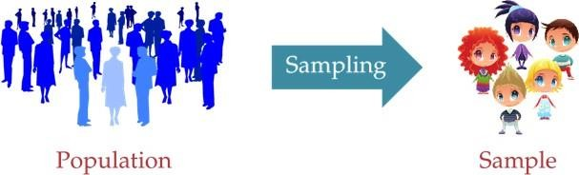Sample is the subset of the population. The process of selecting a sample is known as sampling. Number of elements in the sample is the sample size.

There are lot of sampling techniques which are grouped into two categories as

## Probability Sampling

* + **Non- Probability Sampling**

DR. VAISHALI PAGAIRA

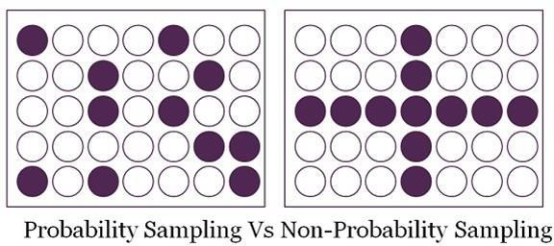

## Probability Sampling

* + This Sampling technique uses randomization to make sure that every element of the population gets an equal chance to be part of the selected sample. It’s alternatively known as random sampling.
  + Simple Random Sampling
  + Stratified sampling
  + Systematic sampling
  + Cluster Sampling

**Simple Random Sampling:** Every element has an equal chance of getting selected to be the part sample. It is used when we don’t have any kind of prior information about the target population.

* + **For example:** Random selection of 20 students from class of 50 student. Each student

has equal chance of getting selected. Here probability of selection is 1/50

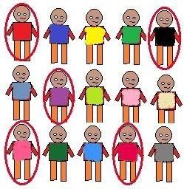

Their evaluation is independent of the other object which the researcher is studying.

The non-comparative scaling techniques can be further divided into:

1. Continuous Rating Scale, and
2. Itemized Rating Scale.

**Continuous Rating Scales:** It is very simple and highly useful. In continuous rating scale, the respondent’s rate the objects by placing a mark at the appropriate position on a continuous line that runs from one extreme of the criterion variable to the other.

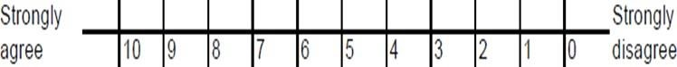Example: Question: How would you rate the TV advertisement as a guide for buying?

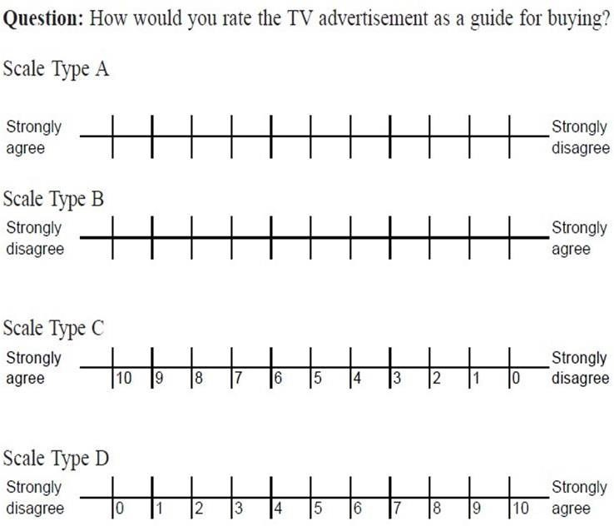

## Itemized Rating Scales:

Itemized rating scale is a scale having numbers or brief descriptions associated with each category. The categories are ordered in terms of scale position and the respondents are required to select one of the limited numbers of categories that best describes the product, brand, company, or product attribute being rated. Itemized rating scales are widely used in marketing research.

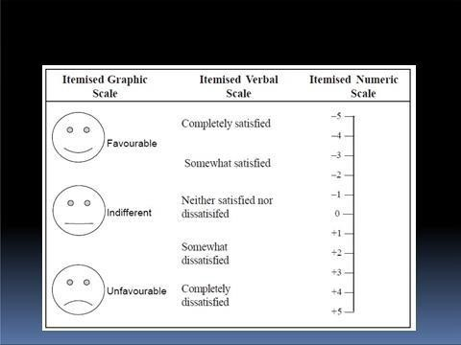

DR. VAISHALI PAGAIRA

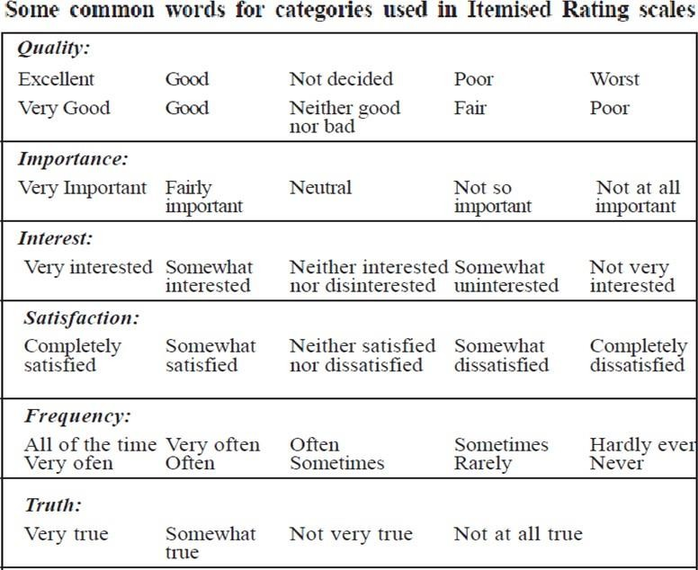

## Qualitative Research Vs Quantitative Research

|  |  |
| --- | --- |
| **Qualitative Research** | **Quantitative Research** |
| Qualitative Research is primarily exploratory research. It is used to gain an understanding of underlying reasons, opinions, and motivations. | Quantitative Research is used to quantify the problem by way of generating numerical data or data that can be transformed into usable statistics. |
| It provides insights into the problem or helps to develop ideas or hypotheses for potential quantitative research. | It is used to quantify attitudes, opinions, behaviors, and other defined variables – and generalize results from a larger sample |
| Qualitative Research is also used to uncover trends in thought and opinions, and dive deeper into the problem. Qualitative data collection methods vary using unstructured or semi-structured techniques. | Quantitative Research uses measurable data to formulate facts and uncover patterns in research. |
| Some common methods include focus groups (group discussions), individual interviews, and participation/observations. | Quantitative data collection methods are much more structured than Qualitative data collection methods. |
| The sample size is typically small, and respondents are selected to fulfill a given quota. | Quantitative data collection methods include various forms of surveys – online surveys, paper surveys, mobile surveys and kiosk surveys, face- to-face interviews, telephone interviews, longitudinal studies, website interceptors, online polls, and systematic observations. |

**Conceptual Framework in Research:**

A conceptual framework in research serves as the foundation upon which a study is built. It provides a roadmap for researchers, guiding them through the exploration, analysis, and interpretation of their findings. Conceptual frameworks are crucial because they:

* Organize Thoughts and Ideas: By outlining key concepts, variables, and relationships, a conceptual framework helps researchers organize their thoughts and ideas, ensuring clarity and coherence throughout the research process.
* Provide Structure: Conceptual frameworks establish the structure of a study, delineating the scope and boundaries within which the research will be conducted. This structure not only streamlines the research process but also aids in focusing efforts on relevant aspects of the topic under investigation.
* Offer Guidance for Data Collection and Analysis: By identifying relevant variables and their interrelationships, conceptual frameworks offer guidance for data collection and analysis. Researchers can use the framework to develop hypotheses, select appropriate research methods, and interpret their findings within a theoretical context.
* Facilitate Communication: Conceptual frameworks serve as a common language for researchers within a particular field or discipline. They facilitate communication and understanding among scholars by providing a shared conceptual framework through which research findings can be discussed, compared, and evaluated.
* Advance Knowledge: Through the development and refinement of conceptual frameworks, researchers contribute to the advancement of knowledge within their respective fields. By elucidating the underlying theoretical principles and mechanisms governing a phenomenon, conceptual frameworks lay the groundwork for future research and theory development.

# Research strategy

A research strategy introduces the main components of a research project such as the research topic area and focus, the research perspective, the research design, and the research methods. It refers to *how* you propose to answer the research questions set and how you will implement the methodology.

Figure shows the four main types of research strategy: case study, qualitative interviews, quantitative survey and action-oriented research. It is likely that you will use one of the first three; you are less likely to use action-oriented research.

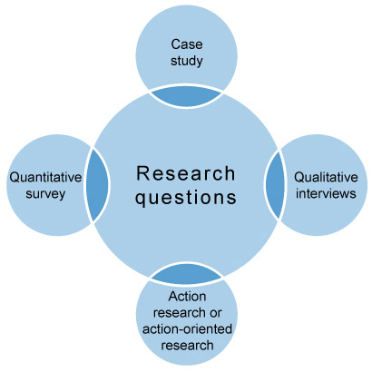

Figure 6 Main research strategies

Here is what each of these strategies entails:

* **Case Study**: This focuses on an in-depth investigation of a single case (e.g. one organization) or a small number of cases. In case study research generally, information is sought from different sources and through the use of different types of data such as observations, survey, interviews and analysis of documents. Data can be qualitative, quantitative or a mix of both.
* **Qualitative interviews**: There are different types of qualitative interviews (e.g. structured, semi-structured, unstructured) and this is the most widely used method for gathering data. Interviews allow access to rich information. They require extensive planning concerning the development of the structure, decisions about who to interview and how, whether to conduct individual or group interviews, and how to record and analyze them.
* **Quantitative survey**: This is a widely used method in business research and allows access to significantly high numbers of participants. The availability of online sites enables the wide and cheap distribution of surveys and the organization of the responses. Although the development of questions may appear easy, to develop a meaningful questionnaire that allows the answering of research questions is difficult. Questionnaires need to appeal to respondents, cannot be too long, too intrusive or too difficult to understand. When using questionnaires decisions have to be made about the size of the sample and whether and when this is representative of the whole population studied. Surveys can be administered to the whole population (census), for example to all employees of a specific organization.
* **Action-oriented research**: This refers to practical business research which is directed towards a change or the production of recommendations for change. Action-oriented research is a participatory process which brings together theory and practice, action and reflection. The project is often carried out by insiders. This is because it is grounded in the need to actively involve participants in order for them to develop ownership of the project. After the project, participants will have to implement the change.

Action-oriented research is*not* exactly action research, even though they are both grounded in the same assumptions (e.g. to produce change).

* It is possible for you to choose a strategy that includes the use of secondary data. Secondary data is data that has been collected by other people (e.g. employee surveys, market research data, census). Using secondary data for your research project needs to be justified in that it meets the requirements of the research questions.
* The use of secondary data has obvious benefits in terms of saving money and time. However, it is important to ascertain the quality of the data and how it was collected; for example, data collected by government agencies would be good quality but it may not necessarily meet the needs of your project.

It is important to note that there should be consistency between the perspective (subjective or objective) and the methodology employed. This means that the type of strategy adopted needs to be coherent and that its various elements need to fit in with each other, whether the research is grounded on primary or secondary data.

**UNIT-V REPORT WRITING**

There are two main types of reports:

## Informational

* + **Analytical**

Both of these reports require analytical thinking and writing, as well as a descriptive overview or background of the topic.

## An Analytical Report:

* + Provides information
  + Analyses information
  + Draws conclusions from the information
  + Recommends action on the basis of the information.

## An Informational Report:

* + - Provides information
    - Does not analyse information
    - Does not recommend action.

For general topics, such as the impacts of privatization of the media, it is likely that you will write analytical reports. For lab reports you would more likely write an informational report on the findings of an experiment you have conducted.

The typical structure of a report includes most, if not all, of the following sections. Refer to your unit outline and your tutor for clarification on what sections you will need to include in your report.

A typical report will include:

* + A Title Page
  + An Abstract
  + A Table of Contents (this must be included if the report is longer than 10 pages)
  + Acknowledgements (if required)
  + An Introduction
  + The Discussion, or body, of the report (the content)
  + Your Conclusion
  + Any Recommendations
  + An Appendix or Appendices
  + And your Reference list.

## Title Page:

The title page will contain:

* The report title, which clearly states the topic of the report
* Full details of the person or persons for whom the report is intended
* Full details of the person or persons who prepared the report
* Date of the presentation of the report (or the date submitted if you are not presenting it).

## Abstract:

The abstract is one of the most important components of the report. It will be read by vastly more people than those who will read the whole report, and needs to provide enough information to invite the audience to read on.

Although the audience will read this first, you should leave the writing of your abstract as the last step. This will allow you to summarise the content of your report in a concise and clear format.

Depending on the length of your report, an abstract is usually no longer than 10% of the paper, or 100-200 words.

An abstract aims to:

* + Provide a brief overview of the whole report
  + Give concise, complete, specific and self -sufficient information that can be easily understood
  + Offer recommendations for executives and managers to base their decisions on.

## Introduction:

Your introduction will:

* + Provide background information on the topic

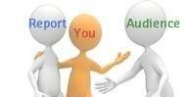

53

* + State the purpose of the report
  + Indicate the scope, including limitations
  + Outline the methods used to gather information
  + Clarify key terms
  + Inform the reader of what your report will cover
  + Give the reader a preview of how the information will be presented.

It will also include your literature review of any publications you have used for your report. For tips on how to write a literature review, follow the link below this slide to Grammarly's post on [*How to Write a Literature Review*.](https://www.grammarly.com/blog/how-to-write-a-literature-review/)

## Content:

The content of your report will depend on its **purpose**.

Your report should contain primary sources if possible (such as observations and interviews), as well as secondary sources to provide explanations of theory and background.

You should further detail the methods of your investigation, including what you did and why, and any issues encountered in the process.

In the body content you will explain the findings gathered from your research, and discuss the implications they hold.

Remember to separate your key ideas and concepts into clear headings and subheadings, so that you break up your report into digestible pieces of information for the reader.

## Conclusion:

Your conclusion will be a summary of the key points you have raised in your discussion. In this, you will need to:

* + Contextualise your observations, findings, and analyses
  + Remind the reader what you have informed them in the body content (i.e. what you researched, what you discovered, what implications or problems this raises)
  + Do NOT include new information here

## Recommendations:

Think of this as an action plan for how to resolve or improve the issue. Try to make your recommendations as realistic as possible, and identif y

DR. VAISHALI PAGAIRA



DR. VAISHALI PAGAIRA

clear paths of how these recommendations could be achieved by the responsible parties.

## Appendix/Appendices:

* + This is a section where you can include further information that is relevant to your topic but did not fit in the body of your report

This can include (but is not limited to) graphs, tables, and raw data collected as part of your investigation.

## Writing a Research Report

|  |  |
| --- | --- |
| **Section** | **Content** |
| **Cover page** | Student name and assignment details. |
| **Table of contents** | List of main sections and sub-sections, with page numbers, including tables, illustrations, reference list, and appendices. |
| **Abstract** | A one-paragraph overview of aims, methods, results, and conclusions. OR One or more pages divided into the same sections as the report. |
| **Introduction** | Research aims and objectives, including any hypothesis.  Rationale for the study, i.e., why the issues for investigation were important or significant. Might define technical or specialist terms.  Outlines scope of the report. Briefly states how report is organised. |
| **Background to study:**  Literature Review How your study fits in | Survey of key literature: summary of major themes, concepts and/or  trends. Situates current research in relation to existing literature; e.g., how it will add to current knowledge, or address existing gap. |
| **Methods:**  How the study was carried out; how data was analysed | Gives precise details of methods and procedures, e.g., study's participants, and how they were chosen; data collection methods (e.g. surveys, interviews, questionnaires, personal observation, case study); process of ethical consent if applicable.  data analysis methods. |
| **Results\*** | Presents results objectively, without discussion.  Can include explanatory or supporting data (e.g., extracts from interviews). Include illustrations, figures or tables. |
| **Discussion\***  (*Results and Discussion might be combined) | Evaluation and discussion of results.  Comments on significant findings, and implications. Might also include:   * whether any initial hypothesis was supported; * whether or not the findings met the aims of the study; * a comparison of your findings with other research; * limitations, flaws or problems in study design or methods. |

DR. VAISHALI PAGAIRA

|  |  |
| --- | --- |
| **Conclusion** | Clearly and concise conclusion to study.  Briefly re-states how well the study design met the study's aims. Emphasises major findings and implications of findings as addressed in discussion section.  Briefly re-caps any faults or limitations covered in full in the discussion section.  If applicable, suggests future research directions. |
| **Recommendations**  (if applicable) | Summarises and lists in order of importance. Might also be numbered. |
| **References** | Alphabetical list of references. Start on new page, attach to end of report, before appendices. |
| **Appendices** | Relevant and necessary material not included elsewhere,  e.g., copy of questionnaires or survey forms; participant consent form; large tables referred to but not included in the body of  report; raw data. Start each appendix on a new page. |